**Codecademy Learners Mockup Data**

**Project Goals**

Use your knowledge of SQL and analyze some mockup Codecademy learners data. There are two tables:

users table:

* user_id
* email_domain
* country
* postal
* mobile_app
* sign_up_at

progress table:

* user_id
* learn_cpp
* learn_sql
* learn_html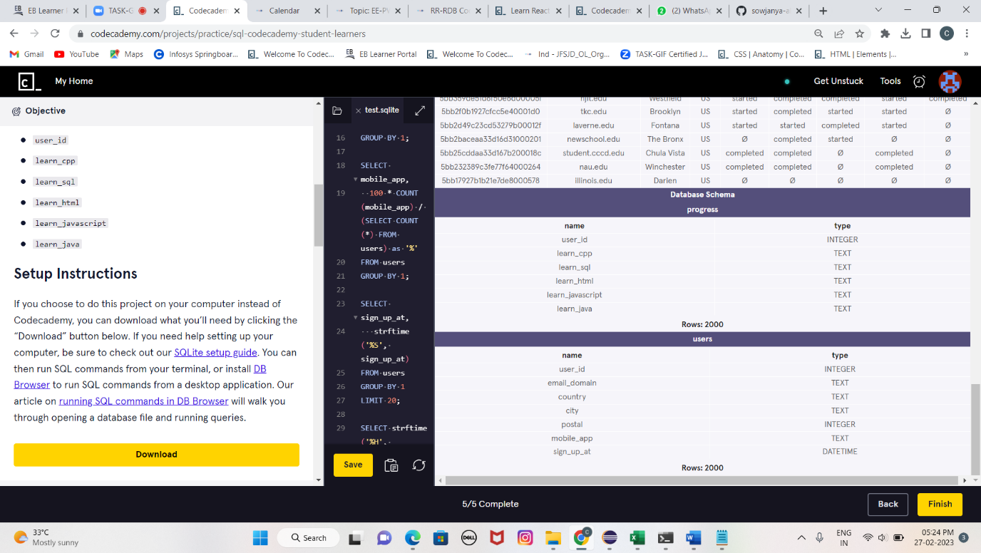
* learn_javascript
* learn_java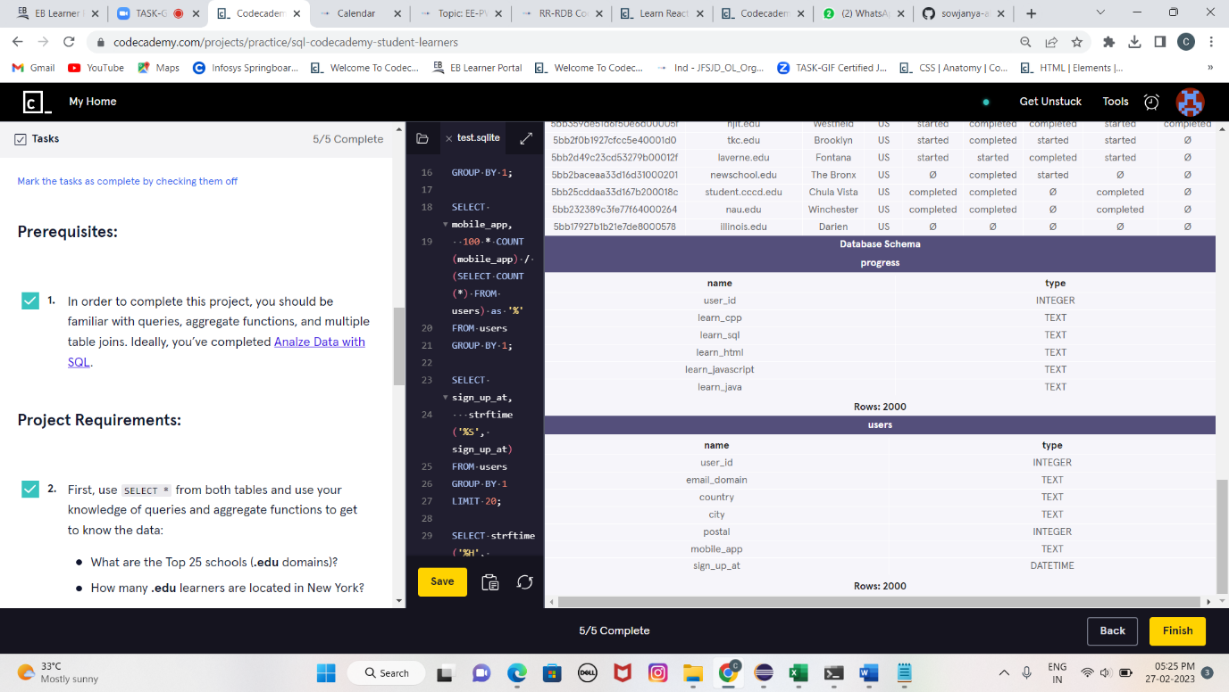

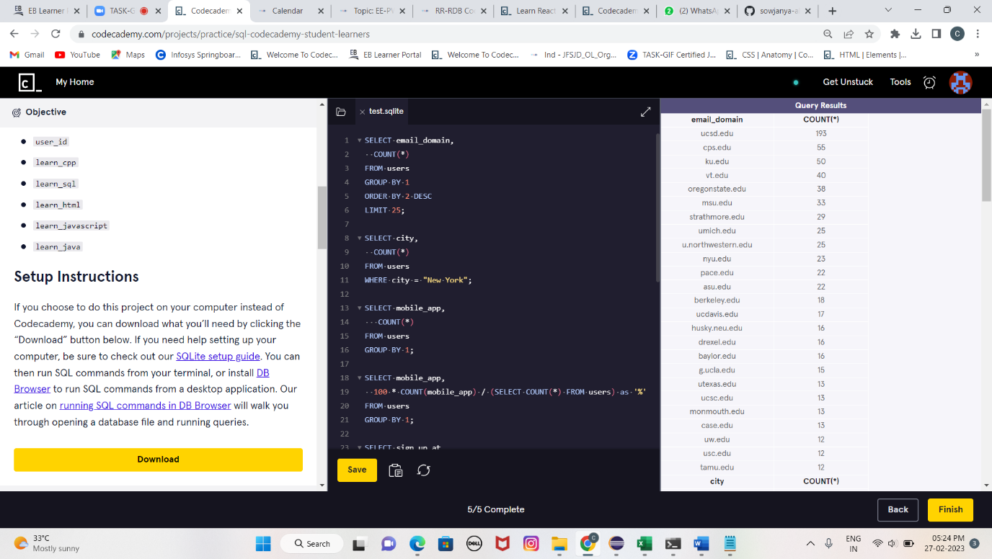SELECT email_domain,

  COUNT(*)

FROM users

GROUP BY 1

ORDER BY 2 DESC

LIMIT 25;

SELECT city,

  COUNT(*)

FROM users

WHERE city = "New York";

SELECT mobile_app,

   COUNT(*)

FROM users

GROUP BY 1;

SELECT mobile_app,

  100 * COUNT(mobile_app) / (SELECT COUNT(*) FROM users) as '%'

FROM users

GROUP BY 1;

SELECT sign_up_at,

   strftime('%S', sign_up_at)

FROM users

GROUP BY 1

LIMIT 20;

SELECT strftime('%H', sign_up_at),

   COUNT(*)

FROM users

GROUP BY 1

ORDER BY 1;

SELECT users.user_id,

   users.email_domain,

   users.city,

   users.country,

   progress.learn_cpp,

   progress.learn_sql,

   progress.learn_html,

   progress.learn_javascript,

   progress.learn_java

FROM users

JOIN progress

  ON users.user_id = progress.user_id

LIMIT 10;

MEKALA SOWJANYA